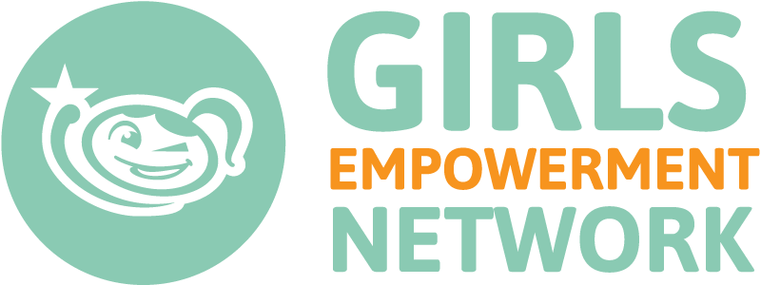
GEN’s Youth Advisory Board Membership Description
The Youth Advisory Board (YAB) is a group of young women who will give feedback about GEN’s programs and how to ensure their relevance to girls. Members of the YAB can be involved as advisers that connect with GEN a few times a year for advice and opinions on programs, or they can be involved directly with monitoring, creating, and volunteering with programs.
Eligibility requirements:
- Young women ages 15-24
- Passion for girls empowerment
- Able to commit to at least a 1 year term that runs from August-July and includes self-paced work at about 2 hours per month.
Membership benefits:
- Ability to positively impact young women in the Central Texas Community.
- Networking with like-minded peers.
- Professional development opportunities like connecting with mentors on GEN’s governing board, experiencing board membership, writing blogs, etc.
- Opportunity to exercising leadership and access to professional references.
Member responsibilities:
- Contribute meaningfully to GEN and the YAB at least 5 times each year. Members are encouraged to engage in activities from all three categories. Below are examples of “contributions:”
  - Activities which help ensure a smoothing functioning of the YAB:
      - Attending in-person meetings/retreats.
      - Holding a leadership position on the YAB.
      - Interview a GEN staff person to report back to the YAB.
      - Meeting at least twice with a governing board mentor.
      - Referring someone to apply for the next year of the YAB.
  - Activities which benefit GEN:
      - Volunteering consistently with a program or in the office.*
      - Responding to a staff person’s request to review a curriculum or program idea.
      - Writing a curriculum or activity.*
      - Sitting on a panel at a GEN event.*
      - Running a crowd sourced fundraising campaign.*
  - Activities which benefit the community/girls:
      - Doing a research project on a specific topic of girls services.*
      - Writing a blog post about a chosen topic.
      - Making a vlog on a chosen topic.
      - Writing a curriculum or activity.*
      - Organizing a service project for other YAB members.*
      - Researching, designing, and leading a breakout workshop at the We Are Girls Conference. *
      - Finding 3-5 articles to be shared on social media and writing a short blurb on why each one is relevant.
      - Other creative project ideas (to be agreed upon by GEN staff.)
* At least one “contribution” must be a larger project. The * denotes ideas for larger projects.
- Attend at least one of two in person meetings each year (held over winter and summer breaks.)
- Actively participate on the YAB Google Community.

